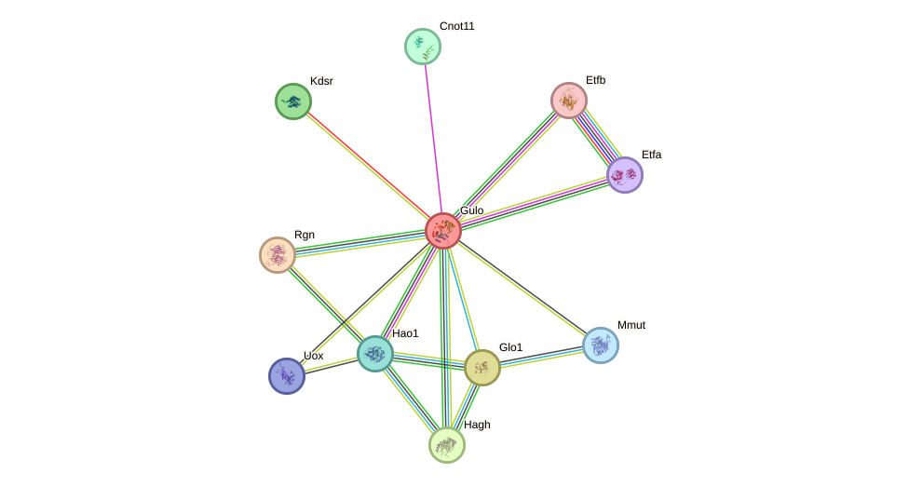
Protein interaction network of rat GULO (L-gulonolactone oxidase) retrieved from STRING (v12.0, Rattus norvegicus). The central node (GULO) represents the functional enzyme present in rat but absent as a functional protein in humans. All surrounding colored nodes represent first-shell interactors. Filled nodes indicate proteins with known or predicted 3D structure. Edges represent predicted functional associations supported by multiple evidence types including curated databases, experimental data, gene co-occurrence, co-expression, and textmining. Each edge color corresponds to a different evidence type as shown in the STRING interface legend. Node size reflects confidence of interaction. In humans, the GULO node is non-functional, disrupting all depicted interactions. The 10 predicted functional partners are ranked by interaction confidence score (range: 0.609-0.974).
Link to detailed image legend on STRING: https://string-db.org/cgi/network?taskId=bG93Vv1jpvZE&sessionId=bz7Re3mlnxtX

Methods
The protein interaction network of functional GULO was retrieved from STRING database (v12.0; string-db.org) using Rattus norvegicus as the query organism, as the human GULO locus produces no functional protein. The query protein "Gulo" (L-gulonolactone oxidase, 440 aa) was searched and the resulting network of predicted functional partners was retrieved using default confidence settings. Network nodes represent proteins, with colored nodes indicating query proteins and first-shell interactors, and filled nodes indicating proteins with known or predicted 3D structure. Edges represent predicted functional associations — not necessarily physical binding — supported by evidence from curated databases, experimental data, gene neighborhood, gene co-occurrence, co-expression, textmining, and protein homology. The network was visualized directly from the STRING interface. Import into Cytoscape was attempted but could not be completed due to software compatibility issues; the STRING network image was retained as the primary figure. The human context was interpreted by treating the central GULO node as non-functional and identifying which interaction partners are consequently disrupted.
Results
The STRING interaction network of rat GULO identified 10 predicted functional partners with confidence scores ranging from 0.609 to 0.974. Interactors clustered into four biologically meaningful groups. First, the highest-confidence interactor was Rgn (regucalcin, score = 0.974), a gluconolactonase that catalyzes a step directly upstream of GULO in the ascorbic acid biosynthesis pathway. Its functional connection to GULO is entirely disrupted in humans, representing the most immediate network consequence of pseudogenization. Second, the glutathione and glyoxalase system was represented by Glo1 (lactoylglutathione lyase, 0.830) and Hagh (hydroxyacylglutathione hydrolase, 0.750), linking vitamin C metabolism to glutathione-dependent detoxification.Third, oxidative metabolism interactors included Hao1 (hydroxyacid oxidase, 0.673) and Uox (uricase, 0.646); notably Uox catalyzes uric acid metabolism, and uric acid serves as a major compensatory antioxidant in humans following vitamin C loss. Its network connection to GULO suggests an evolutionary link between these two antioxidant systems. Fourth, mitochondrial electron transfer flavoproteins Etfa (0.624) and Etfb (0.609) were connected to GULO through shared flavoprotein biochemistry. Both accept electrons from mitochondrial dehydrogenases and, like GULO, belong to the broader family of FAD-dependent oxidoreductases.
Interpretation
Since the human GULO locus produces no functional protein, all 10 depicted interactions are effectively absent in humans. The most functionally significant disruption is the loss of the GULO-Rgn interaction, which severs the final two enzymatic steps of the ascorbic acid biosynthesis pathway simultaneously. The presence of Uox in the GULO interaction network is particularly noteworthy: in most mammals Uox degrades uric acid, keeping levels low, but in humans Uox is also non-functional, so humans independently lost both GULO and Uox. The resulting elevation of uric acid in humans is now understood as a compensatory adaptation, with uric acid serving as a major circulating antioxidant substituting for the lost vitamin C. The network therefore not only illustrates what was lost, but points toward the compensatory reorganization that followed.
Limitation Note
Network visualization in Cytoscape could not be completed due to software compatibility issues. The STRING network image serves as the primary figure for Step 7. Future analysis would benefit from Cytoscape-based visualization with the GULO node explicitly annotated as non-functional and interaction edges weighted by confidence score.

